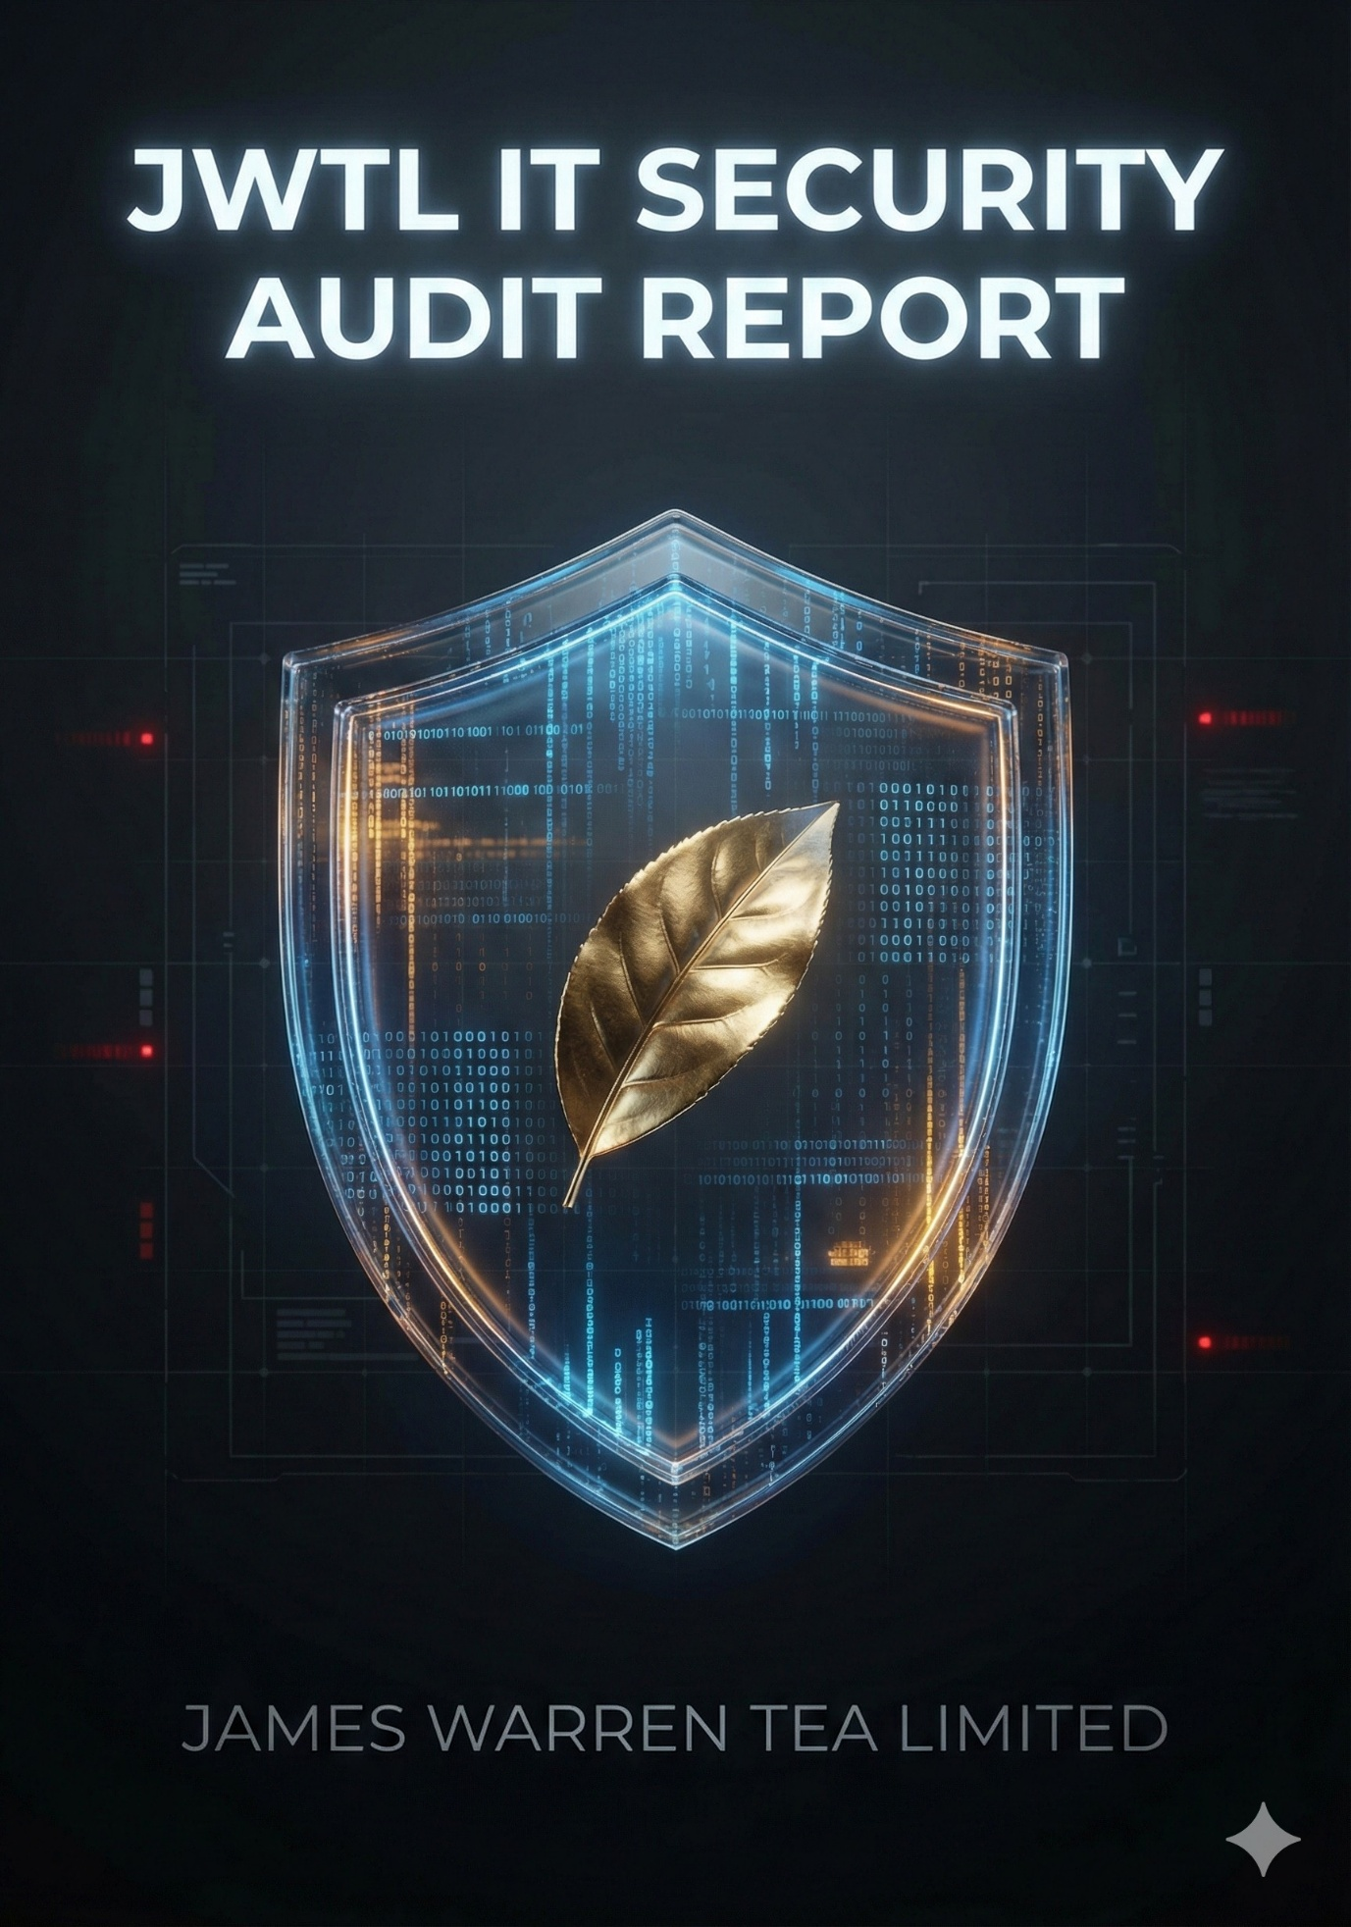

TABLE OF CONTENTS

SECTION A: HEAD OFFICE INFRASTRUCTURE (MASTER CONTROL)
- Executive Summary
- Hardware & Firmware Inventory
- Network Topology & Connectivity Analysis
- Security Configuration Analysis
- Recommendations & Action Plan
SECTION B: ENDPOINT DEVICES (HO) AUDIT REPORT
B1. Desktop & Laptop Inventory Analysis
B2. Mobile Devices (BYOD/Corporate) Security
B3. Peripheral & IoT Devices (HO) Isolation Audit
SECTION C: HEAD OFFICE SERVER INFRASTRUCTURE AUDIT REPORT
C1. Server Inventory and Software Audit
C2. Privileged Accounts
C3. Recommendations & Mitigation Plan
SECTION D: GARDEN INFRASTRUCTURE & CONNECTIVITY AUDIT REPORT
D1. Network & Connectivity
D2. Garden Server Infrastructure
D3. Garden Endpoints
D4 & D5. Network Devices, Security, and Physical Security
D6. Garden User Access & Management
SECTION E: SECURITY CONTROLS (HO + GARDENS) AUDIT REPORT
E1. Antivirus/EDR Solution Analysis
E2. Patch Management
E3. Email Security
E4. Web Security
SECTION F: BACKUP & DISASTER RECOVERY AUDIT REPORT
F1. Backup Solution Analysis
F2. Critical Data Backup Coverage
F3. Disaster Recovery (DR) Plan
SECTION G: ACCESS CONTROL & IDENTITY MANAGEMENT AUDIT REPORT
G1. Privileged Access Management (PAM)
G2. Multi-Factor Authentication (MFA)
G3. VPN Access
G4. Garden User Access
SECTION H: LOGGING & MONITORING AUDIT REPORT
H1. Log Aggregation and Centralization
H2. Local Log Retention
H3. Alerting and Incident Response
SECTION I: VENDOR & AMC MANAGEMENT AUDIT REPORT
I1. Firewall AMC Analysis
I2. Other AMCs and Critical Service Support Gaps
SECTION J: GARDEN-SPECIFIC SECURITY AND USER AWARENESS AUDIT REPORT
J1. Local Security Posture Analysis (All Gardens)
J2. User Awareness and Training
COMPREHENSIVE IT SECURITY AUDIT CONCLUSION AND STRATEGIC MITIGATION PLAN
- Overall Security Posture Assessment
- Consolidated Mitigation Roadmap (Next Steps)

JWTL IT SECURITY AUDIT – REPORT
Objective: Establish a security baseline for James Warren Tea Limited (HO + 4 Gardens)
Methodology: Document, Test, Validate, Report

SECTION A: HEAD OFFICE INFRASTRUCTURE (MASTER CONTROL)
1. Executive Summary
The Head Office (HO) network is the critical nerve center for James Warren Tea Limited, hosting the central firewall, core ERP services, and providing connectivity to four remote gardens (Balijan, Deamoolie, Thowra, Zaloni).
Current Posture Rating: 🟠 MODERATE RISK
- Strengths: The perimeter is guarded by a modern, enterprise-grade firewall (FortiGate-60F) running stable firmware. Hardware redundancy (Active-Active HA) is configured, ensuring resilience against device failure. Connectivity to remote gardens is exceptionally stable with low latency (<50ms), indicating robust P2P/RF links.
- Critical Weaknesses: The environment lacks Log Retention (no SIEM/Syslog) and Configuration Backups. The firewall memory usage is high (70%), and generic admin accounts are in use.

2. Hardware & Firmware Inventory
The perimeter is secured by a Next-Generation Firewall (NGFW).
Component | Specification | Status | Observations
Device Model | FortiGate-60F | ✅ Healthy | Enterprise-grade hardware.
Hostname | JAMES_WARREN_TEA | ℹ️ Info | Clearly identifies the organization.
Firmware | v7.2.9 (build1688) | ✅ Secure | Running a mature patch of the 7.2 branch.
HA Status | Active-Active | ✅ Resilient | Provides load balancing and failover capability.
License Expiry | August 2026 | ✅ Valid | Support and UTM definitions are active for ~2 more years.
System Resources | CPU: ~2-5% (Idle)  RAM: 70% Used | ⚠️ Warning | Memory usage is high (1.3GB of 1.9GB used). This is typical for FGs running heavy IPS/AV engines but requires monitoring.
Specific Findings:
- Explicit Logging: Policy 21 (Lan_To_Wan) explicitly has logging enabled (set logtraffic all). While this is good, the full configuration is required to confirm logging for the main policies (16 and 17). Best practice requires logging on all active traffic-passing policies.

3. Network Topology & Connectivity Analysis

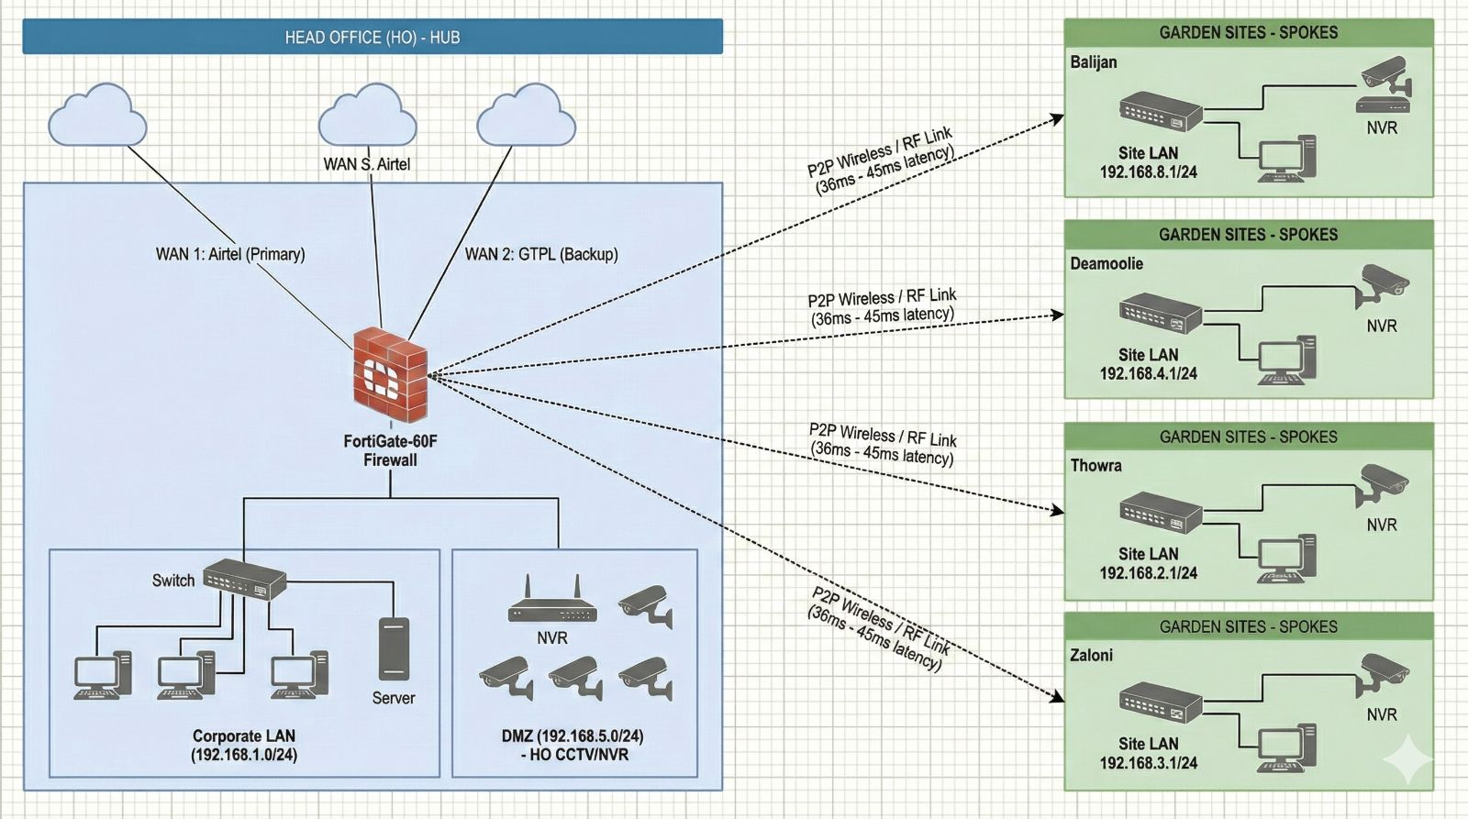
NETWORK DIAGRAM
3.1 Connectivity Architecture
The network operates on a Hub-and-Spoke topology. The Head Office acts as the central hub, connected to remote gardens via Point-to-Point (P2P) Radio Frequency (RF) links.
- WAN (Internet): Connected via Airtel on port wan1 (IP: 122.160.114.1).
- Secondary WAN: A second link exists on wan2 (IP: 10.21.194.129), but routing priority suggests Airtel is primary.
- WAN 3: Connected via Airtel, this internet connection passes through the firewall and connects all the gardens.
- LAN: The internal subnet is 192.168.1.0/24.
3.2 Remote Garden Connectivity (Performance Test)
A ping test was conducted from the HO Server to the Gateway IP of each garden. The results indicate excellent stability for RF links, with latency rivaling wired connections.
Destination Garden | IP Address | Min Latency | Max Latency | Avg Latency | Packet Loss | Link Health
Thowra | 192.168.2.1 | 35ms | 38ms | 36ms | 0% | 🟢 Excellent
Deamoolie | 192.168.4.1 | 35ms | 48ms | 39ms | 0% | 🟢 Excellent
Zaloni | 192.168.3.1 | 43ms | 45ms | 44ms | 0% | 🟢 Excellent
Balijan | 192.168.6.1 | 44ms | 47ms | 45ms | 0% | 🟢 Excellent
Technical Insight:
The routing table indicates static routes for these subnets (192.168.2.0/24 etc.) are directed to 192.168.1.1 via the internal interface.
- Inference: The Firewall itself is not the direct termination point for the Radio links. Instead, a core switch or a separate router at 192.168.1.1 handles the physical radio connections, and the Firewall routes traffic to it.

4. Security Configuration Analysis
4.1 Administrative Access (AAA)
- Admin Accounts: one super-admin accounts exist: admin.
  - ⚠️ Risk: Use of generic names (admin) makes brute-force guessing easier.
- Access Protocols:
  - HTTP (port 80) redirects to HTTPS (port 443). (Good).
  - SSH/Telnet status: Controlled.
- Trusted Hosts: set admin-host '' is configured.
  - 🔴 Critical Risk: This means ANY IP address on the management interface can attempt to login. There is no restriction limiting management access to specific IT subnets.

4.2 Firewall Policies & Rule Base
Review of the policy dump (show firewall policy) reveals the following:
- Policy 19 ("all to all"): set action accept, srcaddr "all", dstaddr "all".
  - Status: disable (Good). If enabled, this would be an "Any-Any" permit rule, a major security violation.
- Policy 1 ("LAN_WAN"): set action accept, UTM enabled (webfilter-profile "G_W_F", ips-sensor "high_security").
  - Status: disable.
- Active Policies:
  - Policy 21 ("Lan_To_Wan"): Allows specific sources (BALIJAN T.E._Lan, 192.168.4.181) to the internet. Logging is enabled (set logtraffic all).
  - Policy 17 ("HO TODEAMOOLIE"): Permits internal traffic to Deamoolie.
Observation: The configuration contains "zombie" policies (disabled rules like Policy 1 and 19) that clutter the config and pose a risk of accidental activation.
4.3 VPN & Remote Access
- User Groups: A group named SSL_VPN_GROUP exists.
- Members: sslvpn1, subhagata, balijan, JWTL, test.
  - ⚠️ Risk: The user account test is active. Test accounts are often created with weak passwords and forgotten, becoming a prime target for attackers.
4.4 Logging & Monitoring
- get log syslogd setting: Status: disable
- get log fortianalyzer setting: Status: disable
- 🔴 Critical Finding: The firewall is not sending logs anywhere. If the device reboots or storage fills up, forensic data is lost. There is no historical record of traffic or attacks.

5. Recommendations & Action Plan
Priority | Finding | Recommendation | Technical Action
🔴 High | No Offsite Logging | Enable Syslog/SIEM immediately. | Configure syslogd to point to a local server or cloud collector.
🟠 Med | Admin Trusted Hosts | Management interface is open to all IPs. | Configure set admin-host to allow only the IT Admin's static IP range.
🟡 Low | Memory Usage | 70% Memory Utilization. | Audit the ips-sensor "high_security". It may be too aggressive for this hardware model.

SECTION B: ENDPOINT DEVICES (HO) AUDIT REPORT
The assessment of Head Office (HO) endpoints reveals significant security and compliance risks driven primarily by the presence of unsupported operating systems and a total lack of management for personal and IoT devices.
Current Posture Rating: 🔴 HIGH RISK
- Primary Concern: Presence of Windows 7 devices, which are End-of-Life (EOL) and lack critical security updates.
- Secondary Concern: Absence of Mobile Device Management (MDM) and network segmentation for IoT devices, expanding the attack surface unnecessarily.

B1. Desktop & Laptop Inventory Analysis
The inventory breakdown shows a heterogeneous environment where security updates cannot be guaranteed across all devices.
Device Type | Count | Operating System | Support Status | Risk Profile
Desktops | 18 | Windows 10 (2) | ✅ Supported | Low to Moderate
 |  | Windows 11 (10) | ✅ Supported | Low
 |  | Windows 7 (6) | ❌ END-OF-LIFE | CRITICAL
Laptops | 5 | Windows 11 (1) | ✅ Supported | Low
 |  | Windows 10 (4) | ✅ Supported | Low to Moderate
TOTAL | 23

Findings (B1)
- EOL Operating System Risk (3 Devices): The six Windows 7 devices are a Critical Security Vulnerability (CVSS 10.0). Microsoft no longer provides public security patches, leaving these machines permanently exposed to known and exploited vulnerabilities (Zero-Day for them).
- OS Fragmentation: Managing patches, updates, and configuration standards across three different major OS versions (Win 7, 10, 11) increases administrative overhead and the chance of misconfiguration.
Recommendations (B1)
Priority | Recommendation | Justification
🔴 High | Immediate Upgrade/Isolation | The six Windows 7 devices must be immediately upgraded to Windows 11, or permanently disconnected from the network. They cannot host critical business applications or handle sensitive data.
🟡 Low | Standardization | Begin planning a phase-out of Windows 10 devices to standardize on Windows 11 for simplified long-term management and feature parity, aligning with Microsoft's roadmap.
NOTE:
Repeated Request for server upgradation has been made.
B2. Mobile Devices (BYOD/Corporate) Security
The current policy on mobile devices presents an unmanaged security hole.
- MDM Solution: None
- Enrolled Devices: None
- Policy: Personal devices are allowed on corporate Wi-Fi.
Findings (B2)
- Data Leakage Risk: Personal devices (Bring Your Own Device - BYOD) accessing the corporate Wi-Fi can expose sensitive internal data to risks like malware, out-of-date security configurations, and unauthorized data copying.
- Lack of Control: Without MDM, IT has zero visibility or control over device compliance. If a personal device is lost or stolen, corporate data (emails, documents) remains accessible, as remote wipe is impossible.
- Policy Gap: Allowing personal devices on the primary corporate network increases the attack surface for the entire organization.

Recommendations (B2)
Priority | Recommendation | Justification
🔴 High | Implement MDM Solution | A solution like Microsoft Intune or a dedicated third-party MDM is required to enforce screen locks, encryption, and enable remote data wipe for corporate-accessed data.
🟠 Med | Establish a Guest/BYOD Network | Create a separate, isolated Guest VLAN for personal devices. This ensures they can access the Internet but are physically blocked from accessing internal LAN resources (servers, file shares, corporate endpoints).
🟠 Med | Formal BYOD Policy | Document and enforce a policy that clearly defines the security requirements (e.g., minimum OS version, antivirus) for personal devices to access any company resource.

B3. Peripheral & IoT Devices (HO) Isolation Audit (Updated)
The strategy for isolating surveillance systems at the Head Office is effective, utilizing a dedicated DMZ network segment. However, other network-connected peripherals and consumer-grade IoT devices remain connected to the main corporate LAN, maintaining a lateral movement risk.
Device Type | Count | Integration Status | Findings
Access points | 2
Printers | 5 | Connected to LAN (192.168.1.x) | Standard, but often unpatched devices.
CCTV/DVR (Hikvision) | 4 | ISOLATED (DMZ 192.168.5.1) | Correctly placed on a segregated DMZ, mitigating risk to the internal LAN.
Access Control (Smart Office) | 2 | Network-connected (192.168.1.x) | Standard for this type of system.
Other IoT (TVs, Tata Play) | 3 | Connected to LAN (192.168.1.x) | Consumer-grade devices with poor security controls.

Findings (B3)
- HO CCTV Isolation Strength: The placement of the CCTV/NVR (192.168.5.1) on a dedicated DMZ (De-Militarized Zone) network segment is a strong security control. This prevents a compromise of the NVR from directly giving an attacker access to the main corporate LAN (192.168.1.0/24) where the servers and workstations reside.
- Lack of IoT Segmentation: Segmentation is missing for all other network-connected peripherals, including networked Printers and Smart Office/TVs. These consumer or basic devices are often easier to exploit and their vulnerabilities allow an attacker to
- Recommendations (B3)
Priority | Recommendation | Justification
🟠 Med | Implement Peripheral VLAN | Create a dedicated, restricted VLAN (e.g., VLAN 99) for all Printers, Access Control, and other IoT devices at the HO. Restrict traffic flow so these devices are blocked from communicating with endpoints and servers.
🟠 Med | Credential Management | Ensure default passwords are changed on all network-connected peripherals, especially the network printers and the DMZ-based Hikvision NVR.
🟡 Low | Inventory Tagging | Create a formal inventory list that tracks the location, IP, and required patching for all IoT and peripheral devices to ensure they are managed.

SECTION C: HEAD OFFICE SERVER INFRASTRUCTURE AUDIT REPORT
The assessment of the Head Office (HO) server infrastructure reveals an immediate and extreme risk profile. The environment is entirely dependent on a single, severely outdated operating system, creating a critical and immediate threat to business continuity and data security.
Current Posture Rating: 🔴 CRITICAL RISK
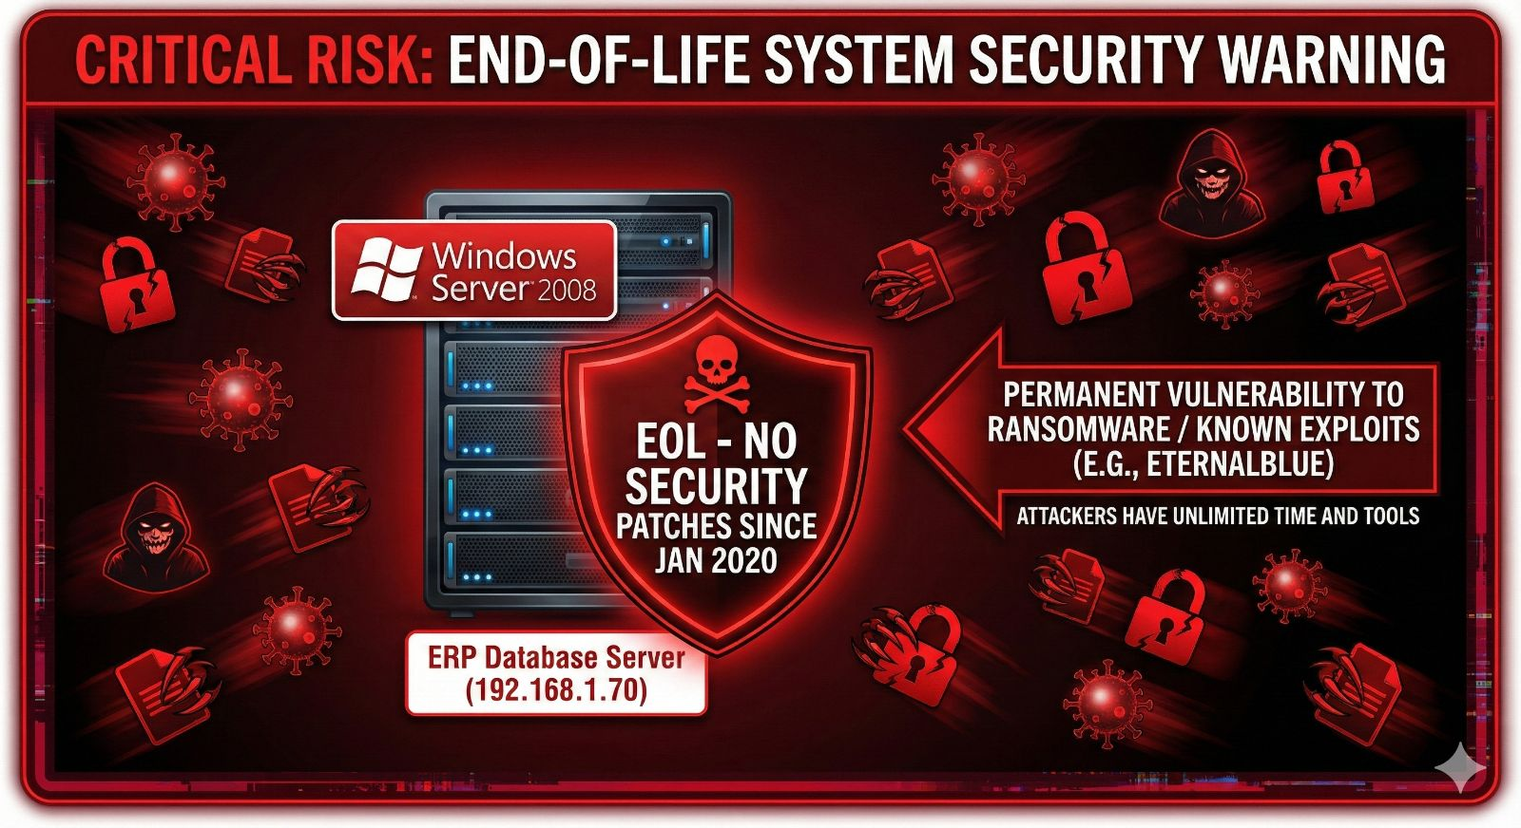
- Primary Concern: Dependence on Windows Server 2008, an End-of-Life (EOL) operating system, which is actively hosting a critical business application (ERP Database).

C1. Server Inventory and Software Audit
The core business application relies on a single point of failure and an operating system that has not received public security patches since 2020.
Hostname | IP Address | Operating System | Role(s) | Last Patch Date | Risk Profile
Server | 192.168.1.70 | Windows Server 2008 | Database for ERP Grill 4.5 | 2008 | EXTREME

Findings (C1)
- Windows Server 2008 End-of-Life (EOL): This is the single most urgent finding in the entire audit. Windows Server 2008 reached EOL in January 2020.
  - Vulnerability Exposure: The server is permanently vulnerable to all security flaws discovered in the last five years, including Ransomware vectors (e.g., WannaCry, EternalBlue exploits).
  - Incompatibility: ERP Grill 4.5, being a 2008 application, is likely running on an unsupported database version (e.g., oracle 16), compounding the EOL risk.
  - Patch Status: The last documented patch date is 2008, indicating a 17-year gap in security updates. This machine is a guaranteed compromise vector for any targeted attack.

C2. Privileged Accounts
Data Status: Zero (0) privileged accounts documented.
- Domain Admins Count: 0
- Enterprise Admins Count: 0
- Service Accounts: 0
Findings (C2)
- Risk of Undocumented Super Admin: A count of '0' privileged accounts is highly unlikely in an operational environment. It indicates that the privileged accounts were not documented/found or that access is handled purely locally on the server, a significant security failure as it bypasses central auditing and control.

4. Recommendations & Mitigation Plan (C1-C2)
This section requires immediate and decisive action. The current server environment is non-compliant with almost all security standards and represents an existential risk to the company's data.
Priority | Finding | Recommendation | Technical Action
🔴 CRITICAL | Windows Server 2008 EOL | IMMEDIATE MIGRATION/ REPLACEMENT. | 1. Procure new hardware/cloud VM. 2. Install Windows Server 2019/2022. 3. Migrate the ERP Grill 4 database to a supported platform (e.g., SQL Server 2019/2022). 4. Decommission and wipe the 2008 server.
🟠 Medium | Lack of Patching | Define and Implement a Patch Management Policy. | Once the server is migrated to a supported OS, implement the Patch Management solution (Section E2 states None) to ensure updates are applied monthly.
🟡 Low | Garden Server Risk | Extend EOL Migration to Gardens. | Apply the same migration plan (Win Server 2022) to the four garden servers to ensure a unified, supported infrastructure across all locations. (A detailed execution plan was already submitted 2 years ago)

SECTION D: GARDEN INFRASTRUCTURE & CONNECTIVITY AUDIT REPORT
The infrastructure across the four remote gardens (Balijan, Deamoolie, Thowra, Zaloni) is consistently deployed but reflects an inherent risk due to the replication of End-of-Life (EOL) operating systems and minimal on-site security controls. The garden network is functional but lacks management visibility and physical security measures.
Current Posture Rating: 🔴 HIGH RISK (Due to EOL OS and lack of control)
- Key Strength: Robust and stable centralized connectivity to the Head Office (HO) via P2P Wireless/RF links, evidenced by low-latency ping results (Section A).
- Key Weaknesses: Total reliance on Windows 7 and Windows Server 2008 (extrapolated from HO/D2 data and zero physical access control for server equipment.

D1. Network & Connectivity
The gardens operate as remote network segments, connected to the HO firewall via P2P wireless.
Garden Name | LAN IP Subnet | Connection Type | WAN IP (Private) - Gateway
Zaloni | 192.168.3.0/24 | P2P Wireless & RF Airtel | 192.168.3.1
Thowra | 192.168.2.0/24 | P2P Wireless & RF Airtel | 192.168.2.1
Deamoolie | 192.168.4.0/24 | P2P Wireless & RF Airtel | 192.168.4.1
Balijan | 192.168.6.0/24 | P2P Wireless & RF Airtel | 192.168.6.1

Findings (D1)
- Stable Central Link: Ping tests (from Section A) confirm excellent connectivity, with average latency between 36ms and 45ms across all four gardens. This confirms the physical link integrity.

D2. Garden Server Infrastructure
Each garden hosts an on-site server, replicating the critical risk profile of the Head Office (Section C).
- Server Hostname: [Garden Name]
- IP Addresses: Zaloni: 192.168.3.0/24, Thowra: 192.168.2.0/24, Deamoolie: 192.168.4.0/24, Balijan: 192.168.6.0/24.
- Roles: File Server and Local Database for ERP Grill 4.5 2008
- OS Version: Windows 10 in Deamoolie, rest all uses Windows 7.
Findings (D2)
- Extreme EOL Risk: The servers are running the End-of-Life (EOL) Windows 7 and 10, representing an immediate and unmitigable security risk identical to the HO server. Each garden has a dedicated single point of failure and exposure to known public exploits.
- Undocumented Patching: The last patch date is missing, reinforcing the suspicion that these servers are unpatched and highly vulnerable, especially considering their role as database and file servers.
Recommendations (D2)
Priority | Recommendation | Justification
🔴 CRITICAL | Server Migration/Upgrade | Prioritize migration of all four garden servers to a supported operating system (Windows 11) to remove the extreme EOL vulnerability across the entire organization.

D3. Garden Endpoints
- Total Endpoints: 4 (1 for each Garden)
- OS Breakdown: Windows 10 in Deamoolie, Rest all Windows 7
Findings (D3)
- Uniform EOL Risk: Only Deamoolie runs Windows 10 all three endpoints in the gardens are running Windows 7, an End-of-Life OS. Any user activity on these machines (email, web browsing) carries an extreme risk of network compromise, as the OS lacks modern security controls and receives no security updates.
Recommendations (D3)
Priority | Recommendation | Justification
🔴 CRITICAL | Endpoint Upgrade | Immediately budget and schedule the upgrade of all four garden endpoints to a supported OS (Windows 11).

D4 & D5. Network Devices, Security, and Physical Security
Component | Status/Brand | Isolation/Management | Findings
Switch | Unmanaged | Unmanaged | No visibility into port status, traffic, or security logs.
Access Points | Yes (All Factories) | Active | All garden factories are equipped with active Wi-Fi coverage for operational mobility.
CCTV/NVR | On same LAN | Not isolated | Same risk as HO (Section B3). A security breach of the CCTV can lead to a server compromise.
Server Room | Office | No Access Control | CRITICAL: Physical security is non-existent; unauthorized personnel can access the server and network equipment.
UPS | Yes | Consistent | Provides basic power continuity.

Findings (D4 & D5)
- Unmanaged Network: The use of unmanaged switches across all four gardens means IT has no control, visibility, or logging capability at the local site level.
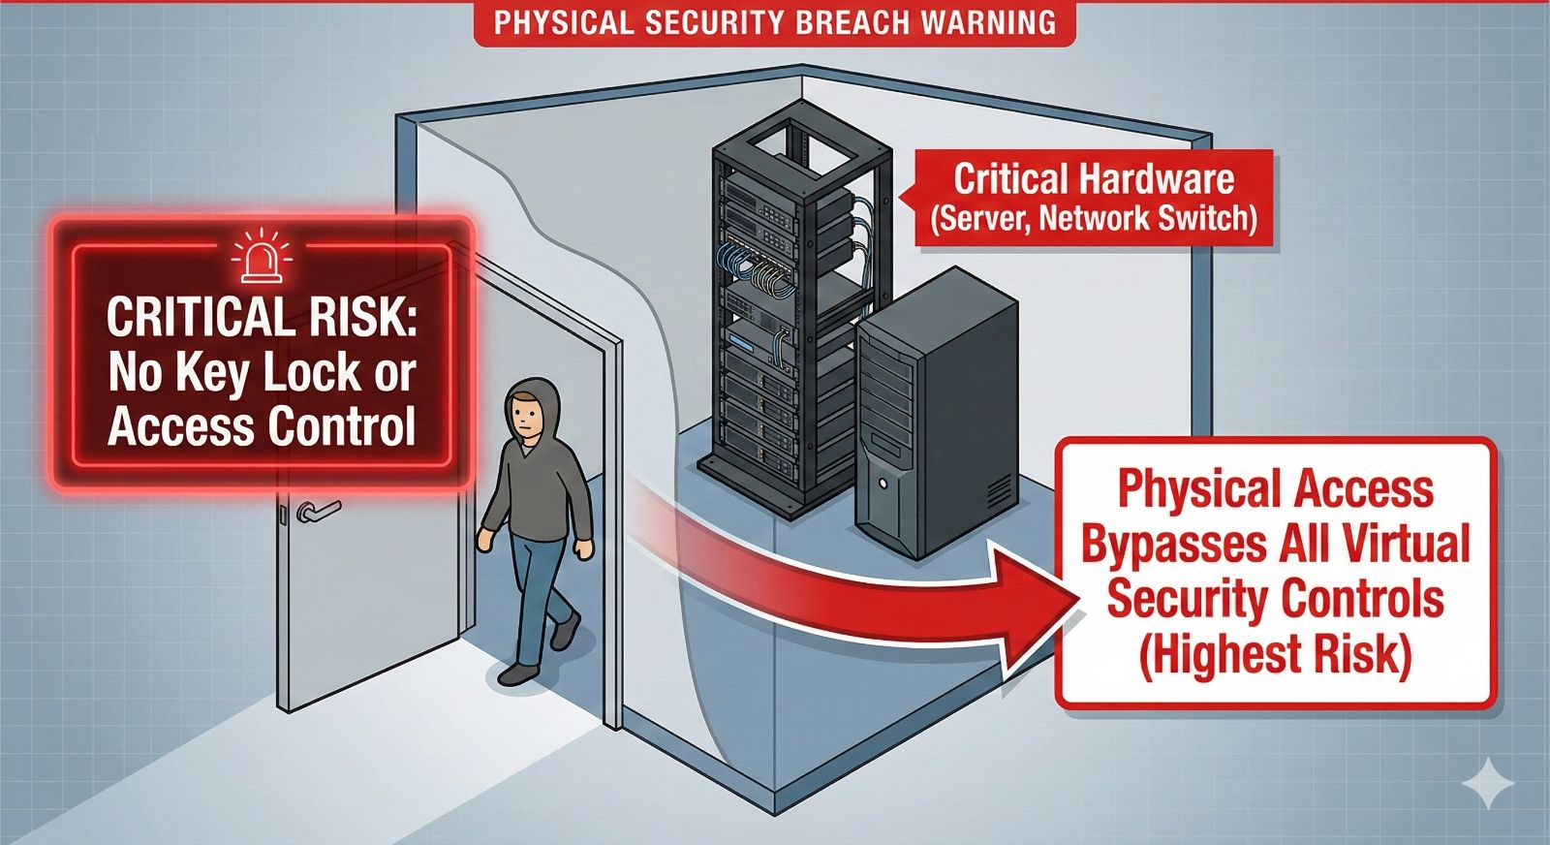
- Physical Security Failure: The servers are located in the "Office" with no access control. This is the highest form of risk, as physical access can bypass all virtual security controls (e.g., direct access to server console, USB boot).
- No Isolation: CCTV/NVR devices are on the same local LAN as the endpoints and servers, facilitating lateral movement for an attacker.

Recommendations (D4 & D5)
Priority | Recommendation | Justification
🔴 CRITICAL | Implement Physical Access Control | Install a basic key lock or keypad lock on the office/server room door to restrict access to authorized personnel only.
🟠 Med | IoT Segmentation | Implement a basic VLAN (or use a separate, dedicated physical switch) to isolate CCTV/NVR devices from the main LAN.
🟡 Low | Switch Upgrade | Evaluate replacing unmanaged switches with affordable managed switches to gain basic monitoring and port control capabilities.

D6. Garden User Access & Management
- Local Admin Users: None documented.
- VPN Access: None (Only HO can connect to Garden).
- Remote Desktop: Enabled, Admin only.
Findings (D6)
- Accountability Gap: The absence of local admin users suggests either a high level of control by HO IT or that generic, undocumented accounts are being used for local maintenance, creating an accountability risk.
- Controlled Remote Access: Remote Desktop is correctly restricted to admin access, which is a positive security measure.
Recommendations (D6)
Priority | Recommendation | Justification
🟠 Med | Document Accounts | Define a policy and immediately document all local administrative accounts (if they exist) and their custodians for accountability and audit purposes.

SECTION E: SECURITY CONTROLS (HO + GARDENS) AUDIT REPORT
The security control posture for both Head Office (HO) and the Gardens is characterized by a strong foundation in Antivirus and Email Security, severely undermined by a complete absence of Patch Management and incomplete endpoint coverage. These gaps introduce vulnerabilities that existing controls cannot mitigate, leading to a Moderate-to-High risk profile.

Current Posture Rating: 🟠 MODERATE TO HIGH RISK (Due to Zero Patch Management)
- Key Strength: Deployment of a modern EDR solution (Bit Defender) with up-to-date definitions and strong firewall-based web filtering.
- Key Weaknesses: No formal system for applying OS/application patches, leaving both servers (Windows Server 2008) and endpoints (Windows 7) exposed.

E1. Antivirus/EDR Solution Analysis
The organization utilizes a modern Endpoint Detection and Response (EDR) solution.
- Product Name: Bit Defender Console
- Version: Latest
- License Expiry: Sept 2026 (Valid)
- Last Definition Update: (Auto updates daily)
- Scan Policy: Weekly
- Coverage: Not all endpoints are covered.
Findings (E1)
- Incomplete Coverage: The fact that "Not all endpoints are covered" negates the effectiveness of the entire EDR deployment. Any uncovered endpoint (HO) can act as an unseen entry point for malware, providing a foothold for lateral movement.
- Effective EDR: Bit Defender is a strong, modern solution with current definitions and a weekly scan policy, which is a good operational standard.

E2. Patch Management
- Solution Used: None
Findings (E2)
- Catastrophic Risk: The complete lack of a Patch Management solution is the single greatest operational risk identified in this section, linking directly to the EOL OS findings in Sections B and C.
- Manual Inconsistency: The absence of a formal process implies patching is either non-existent or performed manually and inconsistently, failing to address critical vulnerability exposure on supported operating systems (Windows 11, Windows Server 2019/2022 after migration).
- Ransomware Exposure: Unpatched vulnerabilities are the primary vector for ransomware and targeted attacks. Even if the EOL servers are removed, the lack of patching on new systems will quickly reintroduce high risk.
Recommendations (E2)
Priority | Recommendation | Justification
🔴 CRITICAL | Implement Patch Management | Select and implement a central patch management solution (e.g., WSUS, SCCM, or a cloud-based service). Define an immediate policy to address high-severity patches (servers first) within 7 days of release.
🟠 Med | Audit 3rd Party Apps | Include patching for critical third-party applications (browsers, PDF readers, Java runtime) in the new policy, as these are often exploited alongside OS vulnerabilities.

E3. Email Security
The organization uses Google Workspace, which includes strong built-in security features.
- Email Platform: Google
- Spam Filter: Built-in (Google)

Findings (E3)
- Solid Platform: Google's built-in security (Gmail) provides robust protection against spam and commodity malware.
- User Weakness: The missing date for the last phishing simulation test highlights a failure to test the human element. User error is the final barrier for highly targeted phishing.
Recommendations (E3)
Priority | Recommendation | Justification
🟠 Med | Mandatory Phishing Simulation | Schedule and conduct quarterly phishing simulation tests for all HO and Garden staff to measure user awareness and track improvement.

E4. Web Security
Web controls are correctly implemented at the perimeter firewall.
- Web Filtering: Firewall-based (FortiGate)
- SSL Inspection: Enabled
- Bypass Categories: None
Findings (E4)
- SSL Inspection is Key: Having SSL Inspection Enabled is a major security strength. It allows the firewall to decrypt and inspect encrypted traffic (HTTPS), preventing malware and command-and-control communication from hiding inside secure sessions.
Recommendations (E4)
Priority | Recommendation | Justification
🟡 Low | Review Blocked Categories | Conduct an annual review of blocked and allowed web categories to ensure the policy remains relevant and does not unnecessarily block essential business resources.

SECTION F: BACKUP & DISASTER RECOVERY AUDIT REPORT
The backup and disaster recovery strategy is highly deficient. While daily, full backups of critical data are being performed and stored both locally and, in the cloud, (a strong point), the custom nature of the solution and a complete absence of a formal Disaster Recovery (DR) Plan elevate the risk to a critical level. Recovery time objectives (RTO) and recovery point objectives (RPO) are unknown.
Current Posture Rating: 🔴 CRITICAL RISK
- Key Strength: Daily Full Backups with 90-day retention, utilizing a 3-2-1 principle (Local NAS + Google Cloud). Critical configs (Firewall/AD) are included.
- Key Weaknesses: No formal DR Plan defined.

F1. Backup Solution Analysis
The organization employs a multi-tier backup approach that ensures some level of data durability.
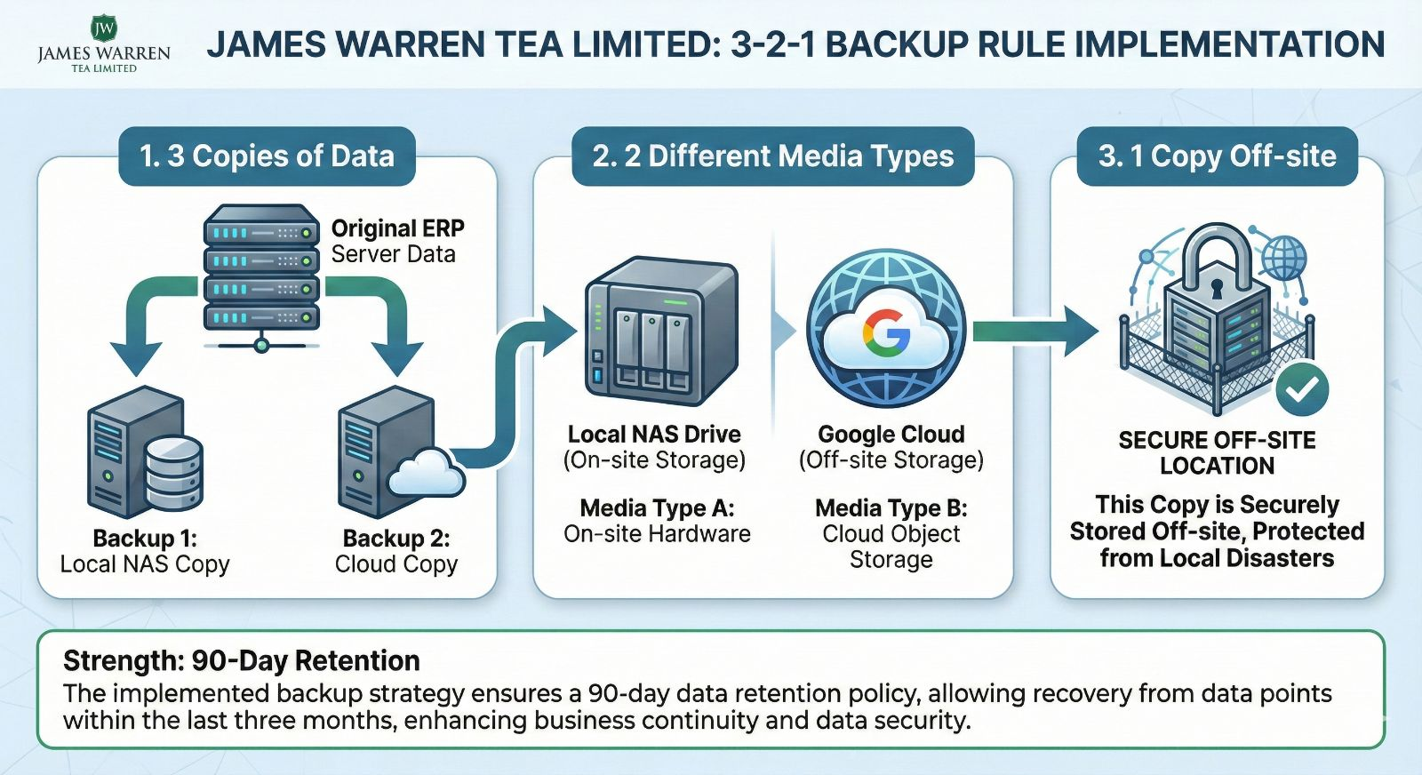
Component | Specification | Schedule/Retention | Status
Product Name | Custom Scheduler & Grill 4.5 | Custom/Non-Standard | ✅ Good
Backup Types | Full | Daily at 06:20 PM | ✅ Good
Retention Period | 90 days |  | ✅ Good
Local Destination | Local NAS |  | ✅ On-site
Offsite Destination | Google Cloud | Weekly | ✅ Off-site

Findings (F1)
- Custom Solution Risk: Relying on a "Custom Scheduler with Grill 4" is non-standard and increases the recovery risk. If the person who developed the script/scheduler leaves, troubleshooting and maintaining the backup mechanism becomes extremely difficult.
- Positive Storage Strategy: The use of both Local NAS (speedy recovery) and Weekly Google Cloud (off-site protection against physical disaster/ransomware) aligns with industry best practices (3-2-1 rule: 3 copies of data, 2 different media, 1 copy off-site).
Recommendations (F1)
Priority | Recommendation | Justification
🟠 Med | Backup Monitoring | Implement an automated email alert or monitoring check for the "Last successful backup job" to ensure daily checks are enforced.

F2. Critical Data Backup Coverage
Critical system configuration data, often overlooked, is fortunately included in the current backup scope.
Critical Asset | Backup Status | Frequency/Method
Firewall Configs | Yes | Every 4th Day
Active Directory | System State Backed up | Yes
All Servers | HO + 4 Gardens | Yes

Findings (F2)
- Comprehensive Coverage: Backing up Active Directory (System State) and all five servers (HO + Gardens) ensures that the critical identity and core file services are protected.
- Firewall Configuration: Backing up the firewall config every 4th day is sufficient to recover the perimeter quickly following a hardware failure.

Recommendations (F2)
Priority | Recommendation | Justification
🟠 Med | Document Recovery Process | Create a step-by-step Disaster Recovery Process Document outlining the exact procedure for restoring the Firewall, Active Directory, and ERP server.

F3. Disaster Recovery (DR) Plan
The entire organization lacks a formal plan or testing process to handle a major disruptive event.
- DR Plan Document: Exists? No
- Last DR Drill Date: March
- RTO (Recovery Time Objective): Not defined
- RPO (Recovery Point Objective): Not defined
- DR Site: None
Findings (F3)
- Lack of Formal DR Plan: The absence of a plan means that in a real disaster (e.g., HO fire, major system failure), IT staff will be improvising under extreme pressure, leading to significantly extended downtime and potential data loss.
- Undefined Objectives: Without RTO (maximum acceptable downtime) and RPO (maximum acceptable data loss), the business cannot accurately measure the impact of an outage or prioritize recovery efforts.
Recommendations (F3)
Priority | Recommendation | Justification
🔴 CRITICAL | Develop Formal DR Plan | Immediately initiate the development of a formal, written Disaster Recovery Plan. This plan must define RTO/RPO targets and include contact lists and escalation matrices.
🟠 Med | Define RTO/RPO | Engage department heads (Finance, Operations) to formally define the maximum acceptable downtime (RTO) and data loss (RPO) for the ERP system and other critical assets.

SECTION G: ACCESS CONTROL & IDENTITY MANAGEMENT AUDIT REPORT
The access control and identity management framework for James Warren Tea Limited is severely underdeveloped. The absence of foundational security layers, particularly Multi-Factor Authentication (MFA) and Privileged Access Management (PAM), combined with generic account use, exposes the organization to account takeover risks, which is one of the primary vectors for ransomware attacks.
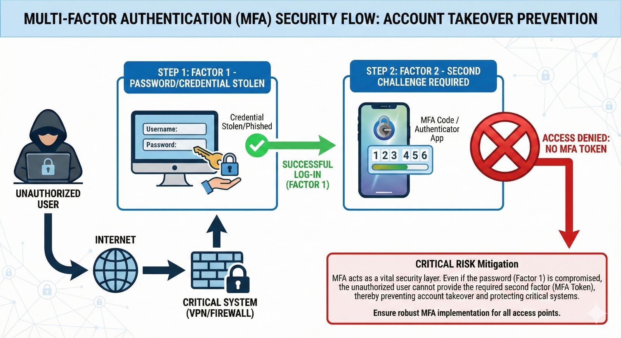
Current Posture Rating: 🔴 CRITICAL RISK
- Key Strength: Remote Desktop Protocol (RDP) access is correctly limited to administrators only.
- Key Weaknesses: Zero MFA enforcement on admin accounts or VPN, no central password vault, and multiple generic/shared accounts (admin, test, JWTL) identified in the firewall configuration.

G1. Privileged Access Management (PAM)
- PAM Solution: None
- Admin Password Vault: Does not exist
- Password Rotation: Not enforced
Findings (G1)
- Exposure of Super-Admin Accounts: The firewall configuration audit (Section A) revealed a super-admin account (admin) and several VPN user accounts (JWTL, test, sslvpn1). These generic, shared, or test accounts are highly vulnerable targets.
- No Credential Control: Without a PAM solution or even a basic password vault, privileged credentials (like server administrator passwords) are likely stored insecurely (e.g., in spreadsheets or unencrypted files) and are never rotated, violating fundamental cybersecurity hygiene.
- Accountability Failure: If multiple staff members know the password for a generic account (like admin), auditing user actions becomes impossible, creating a blind spot for malicious or accidental system changes.
Recommendations (G1)
Priority | Recommendation | Justification
🔴 CRITICAL | Implement Password Vault/PAM | Purchase and implement a centralized, encrypted password vault solution (e.g., KeePass, LastPass Business, or a dedicated PAM tool). All privileged account credentials must be immediately stored here.
🔴 CRITICAL | Eliminate Generic Accounts | Immediately disable or rename generic accounts (admin, test, JWTL) and replace them with unique, named administrator accounts for each staff member for proper auditing.
🟠 Med | Enforce Rotation | Implement a mandatory password rotation policy (e.g., every 90 days) for all privileged accounts.

G2. Multi-Factor Authentication (MFA)
- 2FA on Admin Accounts: No
- 2FA on VPN: No
- 2FA Solution: None
Findings (G2)
- Account Takeover Risk: The total absence of MFA is the single most critical vulnerability related to identity. If an attacker guesses or steals a password, they gain unrestricted access to the network (via VPN) or the firewall (via admin access) without a second challenge.
- Failure to Meet Industry Standards: MFA is considered baseline security and is mandatory for compliance frameworks globally.
Recommendations (G2)
Priority | Recommendation | Justification
🔴 CRITICAL | Implement MFA for All Privileged Access | Enable and enforce MFA for all access methods: VPN access and Firewall/Server administration access. Use either hardware tokens or modern authenticator app solutions.

G3. VPN Access
- VPN Type: IPsec
- Concurrent Licenses: 4
Findings (G3)
- IPsec Protocol: While functional, IPsec is often less flexible for modern MFA deployments compared to SSL VPNs, though the FortiGate can support it. The use of IPsec itself is not a risk but must be secured with MFA (as noted above).
Recommendations (G3)
Priority | Recommendation | Justification
🟠 Med | Maintain User List | Immediately create and maintain an up-to-date list of all authorized VPN users, reviewing it quarterly to revoke access for departed or unauthorized personnel.

G4. Garden User Access
- Local Admin Users: None
- VPN Access: Only HO can connect to Garden
- Remote Desktop: Yes, Admin only
Findings (G4)
- Controlled Remote Access: The restriction of RDP access to administrators only is a strong security practice.
- Accountability Gap: The lack of documented local admin users (as also noted in D6) remains a systemic accountability gap across all remote sites.
Recommendations (G4)
Priority | Recommendation | Justification
🟡 Low | Formal RDP Control Review | Define a clear policy for RDP use (when and by whom) and restrict source IPs to only the HO administration subnet to minimize exposure.

SECTION H: LOGGING & MONITORING AUDIT REPORT
The logging and monitoring framework is non-existent, representing a critical blind spot in the organization's security posture. Without centralized log aggregation, defined retention policies, or alerting mechanisms, James Warren Tea Limited operates with zero ability to perform proactive threat hunting, forensic analysis, or effective incident response.
Current Posture Rating: 🔴 CRITICAL RISK
- Key Weakness: Zero centralized log aggregation (SIEM/Syslog).
- Impact: Any security incident, data breach, or system failure cannot be forensically investigated beyond the brief, local logs on the individual systems, which are often quickly overwritten or deleted.

H1. Log Aggregation and Centralization
- SIEM Solution: None
- Logs Sent to SIEM: None
Findings (H1)
- Critical Logging Failure: The audit of the FortiGate firewall (Section A, CLI output) confirms that both Syslog (get log syslogd setting: disable) and FortiAnalyzer (get log fortianalyzer setting: disable) logging are explicitly disabled.
- No Single Source of Truth: This means that security events (e.g., failed logins, policy violations, virus detections, VPN activity) are either stored only on the firewall's small local disk or on the individual server/endpoint devices.
- Audit Failure: In the event of a security breach, there is no centralized, tamper-proof repository to reconstruct the attacker's activities, determine the point of entry, or identify the data compromised.
Recommendations (H1)
Priority | Recommendation | Justification
🔴 CRITICAL | Implement SIEM/Syslog Solution | Immediately procure and implement a centralized log management solution (e.g., open-source Syslog server, or a cloud SIEM/LMS) to aggregate logs from the Firewall, Active Directory, and all Servers.
🔴 CRITICAL | Activate Firewall Logging | Enable Syslog forwarding on the FortiGate firewall and direct all relevant security and traffic logs to the new log management solution.

H2. Local Log Retention
- Firewall Logs: None
- AD Security Logs: None
- Server Event Logs: None
Findings (H2)
- Retention Policy Gap: The policies for how long and where logs are kept are undefined. This poses a significant risk for both security and compliance. Regulatory requirements (e.g., ISO 27001, local data protection laws) typically mandate long-term, specific log retention periods (e.g., 90 days to 1 year).
- Overwrite Risk: Without defined retention and archiving, local device logs (which are often saved in circular buffers) will quickly be overwritten by new events, making retrospective investigation impossible.
Recommendations (H2)
Priority | Recommendation | Justification
🟠 Med | Define Retention Policy | Formally define log retention periods for all critical systems (e.g., 90 days local storage on the SIEM, 1 year archived to low-cost cloud storage).
🟠 Med | Configure Server Log Size | Ensure that Windows Server logs (especially Security logs) are configured with sufficient maximum size to prevent rapid overwriting before they can be forwarded to the central SIEM.

H3. Alerting and Incident Response
- Alert Recipients: None
- Alerts Configured: None
- Escalation Matrix: No
Findings (H3)
- No Proactive Response: In the current state, even if a critical security event (e.g., brute-force attack on VPN, high-severity virus detected, ISP link failure) is logged locally, no one is notified. This prevents prompt intervention, allowing attacks to progress undetected.
- Undefined Escalation: The absence of an Escalation Matrix means the organization has no predefined process for handling incidents. There is no documented list of who to contact, in what order, and when (e.g., IT staff vs. Management vs. External Vendor), guaranteeing a chaotic and slow response during a crisis.
Recommendations (H3)
Priority | Recommendation | Justification
🔴 CRITICAL | Establish Critical Alerting | Define and configure alerts for mission-critical events (e.g., 50+ failed login attempts in 5 minutes, EDR detection on a server, Firewall HA failure) and ensure they are immediately delivered to the responsible IT staff.
🟠 Med | Create Escalation Matrix | Develop a formal Incident Response and Escalation Matrix. This document must clearly define the roles, responsibilities, and contact information for security, operations, and business management to be involved in an incident.

SECTION I: VENDOR & AMC MANAGEMENT AUDIT REPORT
The vendor and Annual Maintenance Contract (AMC) management for James Warren Tea Limited is inconsistent. While critical security components (Firewall and Antivirus) are appropriately covered with valid, high-level support contracts, several fundamental operational systems, including Backup, and Servers, lack any formal support agreement. This creates a reliance on ad-hoc support for key services, potentially leading to lengthy and costly downtime.
Current Posture Rating: 🟠 MODERATE RISK (Due to Gaps in Operational Support)
- Key Strength: Managed support for perimeter security (FortiGate) and endpoint protection (Bit Defender) from a known vendor (Computer Exchange).
- Key Weaknesses: No formal support contract for Backup, or the critical (and vulnerable) Windows Server infrastructure.

I1. Firewall AMC Analysis
The perimeter defence system is well-supported, minimizing hardware failure downtime.
- Vendor Name: Computer Exchange
- Contract Period: Valid until Aug 2026
- Support Level: 24x7
- Vendor Portal Access: On call
Findings (I1)
- Strong Support: The 24x7 support level ensures that hardware failures or critical configuration issues can be addressed by the vendor around the clock, aligning with high availability standards.
- Long-Term Validity: The contract is valid for an acceptable duration (approx. 2 years), providing stability.
Recommendations (I1)
Priority | Recommendation | Justification
🟡 Low | Periodic Review | Schedule a review of the Firewall AMC six months prior to the August 2026 expiration to ensure continuous coverage and avoid a lapse in support.

I2. Other AMCs and Critical Service Support Gaps
The support status for other key infrastructure components highlights significant operational continuity risks.
Product | Vendor | Expiry Date | Support Level | Findings & Risk Profile
Antivirus | Computer Exchange | Sept 2026 | 24x7 | ✅ Supported. High-level support for endpoint security.
Backup | None | None | None | 🔴 CRITICAL RISK: The custom backup solution (Section F) has no vendor support. If the software fails or data is corrupt, there is no external expertise to assist in recovery.
Servers | None | None | None | 🔴 CRITICAL RISK: The highly vulnerable EOL Windows Server infrastructure (Section C) has no hardware or OS support contract. Any failure will result in catastrophic, unmitigated downtime.

Findings (I2)
- Backup Solution Risk: The Custom Scheduler/Grill 4 backup solution, which is responsible for all company data, has no support contract. This is a severe oversight, as system recovery is the most critical and complex procedure.
- Server Support Void: Given that the HO and Garden servers are running EOL Windows Server 2008, a support contract for a new, supported operating system and its underlying hardware is essential. Operating the current EOL hardware without a maintenance contract guarantees major delays during any hardware failure.

Recommendations (I2)
Priority | Recommendation | Justification
🔴 CRITICAL | Establish Server AMCs (New Hardware) | As part of the server migration project (Section C), ensure all new server hardware is covered by a vendor warranty/AMC (e.g., 5 years Next Business Day or 24x7).
🔴 CRITICAL | Backup Support Strategy | Since the backup is custom, IT must engage a third-party consultant (or the vendor who provided the custom solution) for a support agreement covering the custom solution's operation and recovery procedures.
🟠 Med | Document Internal Support | For the custom backup solution, ensure detailed internal documentation is created to enable internal IT staff to handle common issues without external support (as noted in F1).

SECTION J: GARDEN-SPECIFIC SECURITY AND USER AWARENESS AUDIT REPORT
Section J addresses the local operational security posture and user awareness across the four remote gardens (Zaloni, Thowra, Deamoolie, Balijan). The findings reveal a consistent reliance on minimal local infrastructure and a complete absence of security training, creating a high level of operational risk exacerbated by the EOL systems documented in previous sections.
Current Posture Rating: 🔴 HIGH RISK
- Key Strength: Consistent deployment of UPS and 4G backup internet across all sites, providing basic power and connectivity resilience.
- Key Weaknesses: Zero security training or phishing reporting mechanism, and no dedicated local IT presence, leading to extended time-to-fix for local issues and a high risk of user-initiated breaches.

J1. Local Security Posture Analysis (All Gardens)
The local security architecture relies on minimal on-site resources, placing a heavy burden on central Head Office IT.
Component | Status (All Gardens) | Impact/Risk
Local IT Staff | No | Response Delay: All local issues (hardware, printing, user issues) must be resolved remotely or via travel, increasing Mean Time to Resolution (MTTR).
Onsite Server Backup | None | Critical Recovery Risk: Localized data loss (e.g., failed HDD) requires recovery over the slow P2P link from HO/Cloud, significantly delaying recovery (high RTO).
4G Backup Internet | Airtel | Resilience: Provides a necessary secondary link if the primary P2P wireless connection fails.
Power Backup | UPS | Resilience: Provides short-term power continuity for safe server shutdown.

Findings (J1)
- Missing On-Site Backup: The lack of any on-site server backup mechanism is a critical operational failure. Restoring a local database (ERP Grill 4.5) or file server from a remote HO NAS or Google Cloud (as per Section F) over a limited bandwidth P2P link could take days, leading to unacceptable business downtime.
- No Local IT Support: The reliance on remote support for five different physical locations increases response times for incidents that require physical intervention (e.g., device reboots, cable faults, physical security breaches).

Recommendations (J1)
Priority | Recommendation | Justification
🔴 High | Implement Onsite Server Backups | Purchase simple local NAS/USB drives for each garden server to perform a daily, local backup. This drastically reduces RTO for small incidents.
🟡 Low | Designate Local "Tech Point" | Assign and train a non-IT staff member at each garden as a "Tech Point" for basic troubleshooting (e.g., reboot devices, check cable status) to reduce HO IT travel/remote time.

J2. User Awareness and Training
User awareness is a critical factor in security, yet this area is completely neglected.
Component | Status (All Gardens) | Impact/Risk
Security Training | None |  | CRITICAL: Staff are untrained on identifying phishing, malware, or safe handling of company data, making them the weakest security link.
Phishing Reporting | None |  | CRITICAL: If a user identifies a phishing attempt, there is no formal process to report it, allowing the malicious email to potentially spread unchecked to other users.
IT Support Contacts | Posted in all gardens |  | Good Practice: Ensures users know who to contact during an issue.

Findings (J2)
- Total Lack of Training: Zero security training means all employees are vulnerable to modern social engineering attacks, credential harvesting, and phishing. This is a foundational security flaw.
- No Incident Channel: The lack of a phishing reporting mechanism prevents the organization from quickly mitigating a live threat (e.g., removing a compromised email from all user inboxes before it is clicked).

Recommendations (J2)
Priority | Recommendation | Justification
🔴 CRITICAL | Mandatory Security Training | Implement a mandatory, annual security awareness training program for all staff (HO and Gardens), focusing on phishing, password hygiene, and data handling.
🟠 Med | Establish Reporting Process | Define a clear, simple process for reporting suspicious emails (e.g., dedicated email inbox or using the "Report Phishing" button in Google Workspace). Communicate this process widely.

COMPREHENSIVE IT SECURITY AUDIT CONCLUSION AND STRATEGIC MITIGATION PLAN
This section summarizes the findings from the technical audit of all systems across the Head Office (HO) and four remote Gardens (Balijan, Deamoolie, Thowra, Zaloni) consolidating the identified risks into a phased remediation roadmap.

1. Overall Security Posture Assessment
Based on the audit findings across 11 key security domains, the overall posture for James Warren Tea Limited is classified as CRITICAL RISK. While the organization benefits from modern perimeter security hardware and resilient P2P/RF links to its remote sites, these strengths are entirely nullified by systemic, fundamental failures in operating system life cycle management, identity control, and security operations (SecOps).

Risk Level | Area(s) of Finding | Description
🔴 CRITICAL | Server & Endpoint OS | Windows Server 2008 and Windows 7 are End-of-Life (EOL). These systems are permanently vulnerable to all known exploits and must be decommissioned immediately.
🔴 CRITICAL | Identity & Access | Total absence of Multi-Factor Authentication (MFA) for VPN and administrative accounts, making account takeover the highest probability attack vector. No Privileged Access Management (PAM) or central password vault.
🔴 CRITICAL | Security Operations (SecOps) | No Patch Management, no centralized logging (SIEM/Syslog), and no formal Disaster Recovery (DR) Plan or restore testing. The organization is blind to attacks and unprepared for recovery.
🔴 CRITICAL | Physical Security (Gardens) | Zero access control for server rooms/office areas housing critical hardware at the Garden sites.
🟠 MODERATE | Endpoint Management | Bit Defender does not cover 100% of endpoints. Most IoT devices (excluding HO CCTV) are not segmented.

2. Consolidated Mitigation Roadmap (Next Steps)
The following action plan is prioritized by risk severity and recommended phasing:
Phase 1: Immediate Critical Risk Remediation
Priority | Area | Action | Impact
1. | Server/OS (C1, D2) | Isolate and Plan EOL Migration. Immediately isolate all Windows Server 2008 machines from the internet and initiate a project plan to migrate the ERP Grill 4 DB and File Server roles to Windows Server 2022. | Eliminates the largest security hole in the network.
2. | Identity (G1, G2) | Enable MFA on VPN. Immediately enforce Multi-Factor Authentication (MFA) for all VPN users (via FortiGate) and all administrator accounts. | Protects the network from credential theft and account takeover.
3. | Patch/AV (E1, E2) | Patch Management & AV Coverage. Close the Bit Defender coverage gap to 100%. Procure and deploy a basic Patch Management solution (e.g., WSUS) to secure all supported systems. | Ensures supported systems receive critical security fixes.
4. | Gardens (D5) | Physical Access Control. Install basic key/pin-pad locks on all Garden Server/Office rooms to prevent physical access to equipment. | Addresses the ultimate security failure: physical access.
5. | Logging (H1) | Enable Syslog. Install a free/low-cost Syslog server and configure the FortiGate to immediately forward all security and traffic logs. | Provides basic visibility for forensic investigation.

Phase 2: Operational Maturity & Resilience
Priority | Area | Action | Impact
6. | Disaster Recovery (F3) | DR Plan & Restore Test. Develop a formal Disaster Recovery Plan defining RTO/RPO targets. Conduct the first test restore of the ERP database from backup media (NAS/Cloud). | Validates the ability to recover the business from a failure.
7. | User Awareness (L2) | Launch Training. Conduct mandatory, basic security awareness training for all staff, focusing on phishing and reporting procedures. | Strengthens the human firewall against social engineering.
8. | Access Control (G1) | Implement Password Vault. Deploy an encrypted password vault solution for all privileged and administrative credentials to enforce secure storage and rotation. | Removes the risk of insecure password storage.

Phase 3: Strategic Improvement & Documentation
Priority | Area | Action | Impact
9. | Documentation (A2) | Finalize Documentation. Document all administrative accounts and internal support processes for the custom backup solution. | Improves troubleshooting efficiency and reduces reliance on tribal knowledge.

